|  |  |
| --- | --- |
|  | **MB Rail Consultancy Limited**  Suite 34, Bonnington Bond  2 Anderson Place  Edinburgh  EH6 5NP |

Jane,

The fee for meeting room rental on July 11th to Facilitate FOSG meeting is £325 + 20% VAT,

Total £390.

Signed,

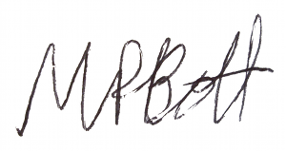

Dr Matthew Bott - PhD, MEng, MIEEE

Director.